Francisco Galvez
CIS480
5.2 Assignment – Project Description
11/2/2024

Project Name: FilmHub Web App
GitHub Link: https://github.com/fgalv12/filmhub-app
Admin Info: admin@email.com Psw: admin1234!@

- Purpose of the Application:
The purpose of this web application is to provide users with an application to search for movies based on various criteria such as name, genre, release year, and rating. Users will also have the option to save their favorite titles to a personal watchlist. The goal is to create a simple interface that delivers quick and accurate search results, enhancing the user experience for movie fans. The end-users are individuals who enjoy watching movies and are looking for an efficient way to find new content or specific titles.

- Programming Languages and Technologies:
- Frontend: ReactJS
- Backend: Node.js with Express.js
- Database: MongoDB
- API Integration: The Movie Database (TMDb) API for accessing movie data

- Hosting Platform:
The web application will be hosted on GitHub.

- Data Storage:
- User Data: Stored in a MongoDB database, including user credentials and watchlist information.
- Movie and Show Data: Retrieved from the TMDb API in real-time to ensure up-to-date information.

- Security Measures:
- User Authentication: Implement secure user registration and login functionalities.
- Input Validation: Clean and validate all user inputs to prevent NoSQL injection and XSS attacks.
- Secure Communication: Use HTTPS to encrypt data transmission between the client and server.
- Rate Limiting: Implemented rate limiting using express-rate-limit to prevent brute-force attacks and abuse of API endpoints.
- HTTP Headers Security: Utilized Helmet.js to set secure HTTP headers, protecting against well-known web vulnerabilities.
- CORS Configuration: Configured CORS to restrict resource access to trusted domains, enhancing security against cross-origin attacks.
- Password Requirements: Enforce strong password requirements that include minimum length, numbers, and special characters.

- Presentation Delivery Method:
I will create a PowerPoint presentation and present the project, which will be recorded and uploaded to OneDrive. A shareable link will be provided to the instructor.

- Database Schema:
User
Id | int
firstName | String
lastName | String
email | String
password | String
watchlist | array

Watchlist
Id | int
movieId | int
title | String
posterPath | String
addedDate | String
notes | String
priority | Int

Movie (API)
Id | int
title | String
rating | int
overview | String
releaseDate | String
genre | String
posterPath | String
createdDate | String

Final:
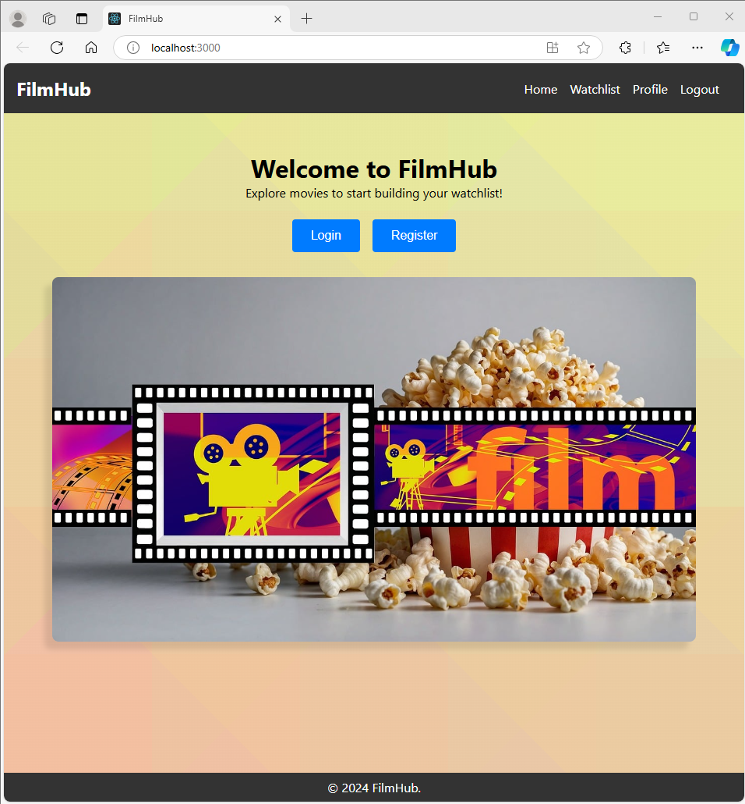

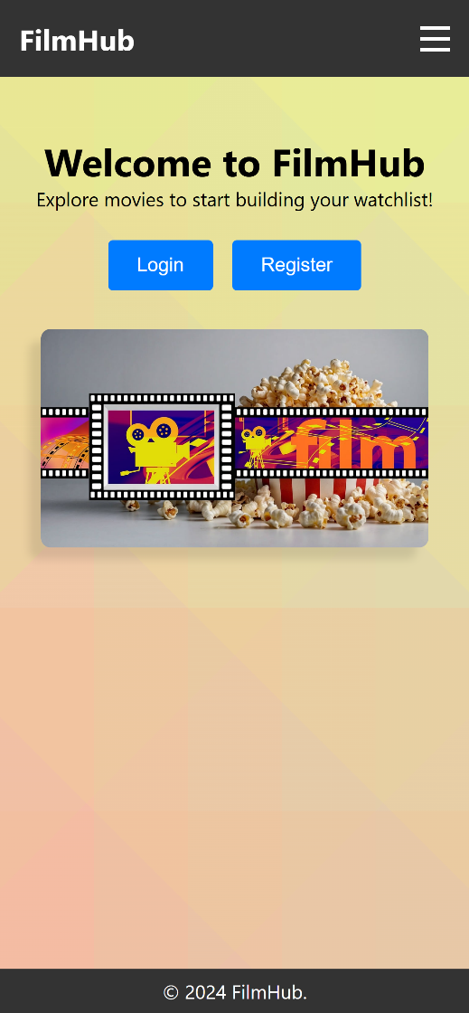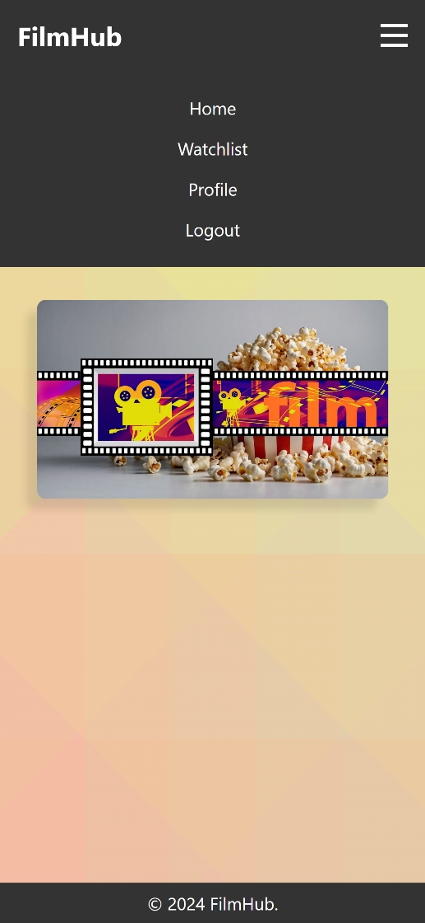

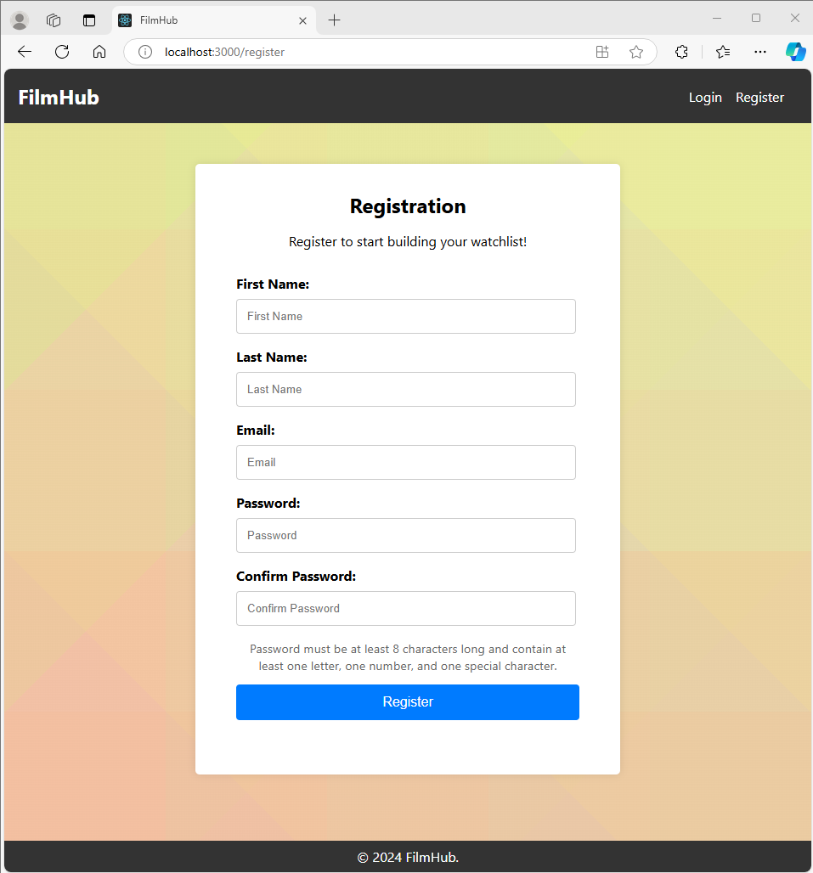

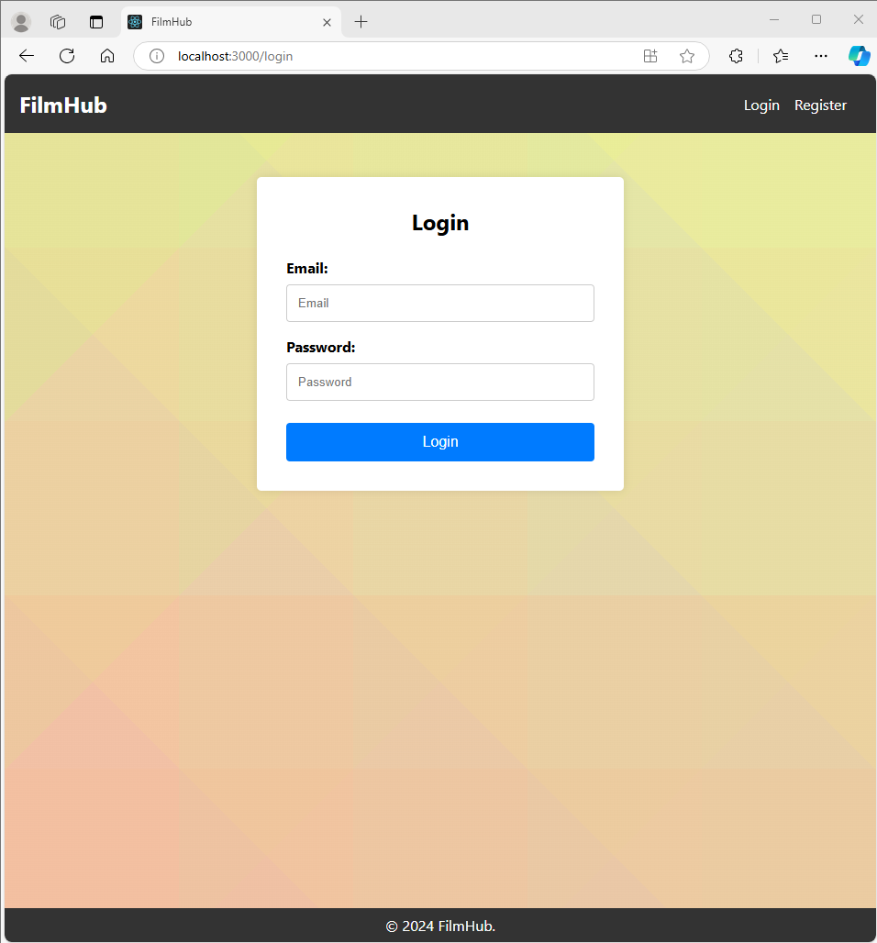
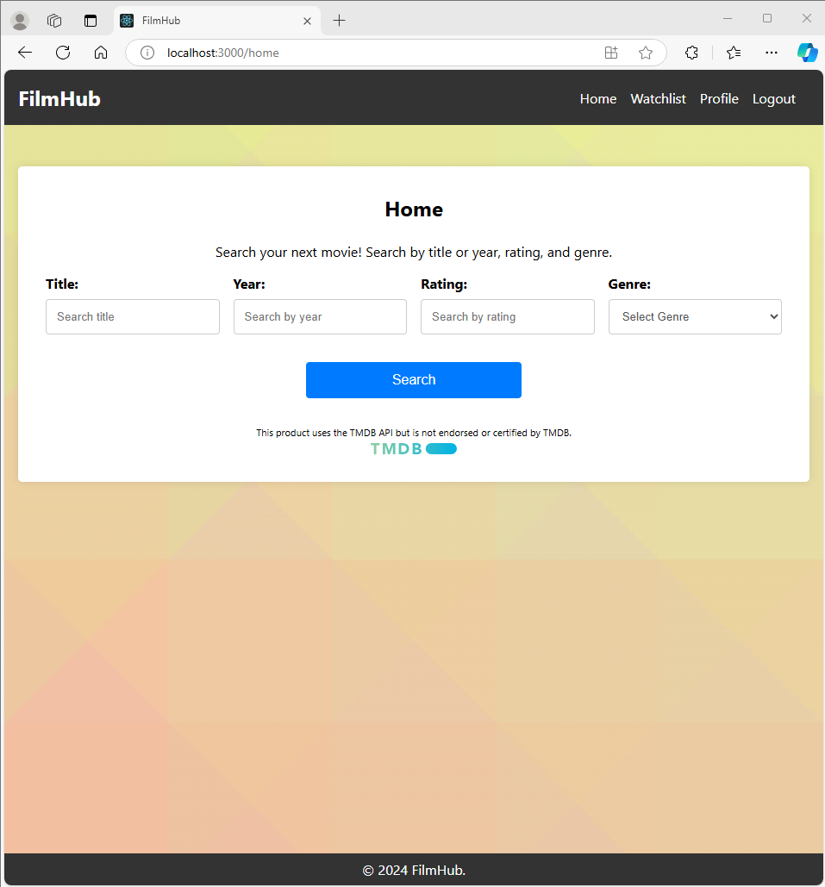
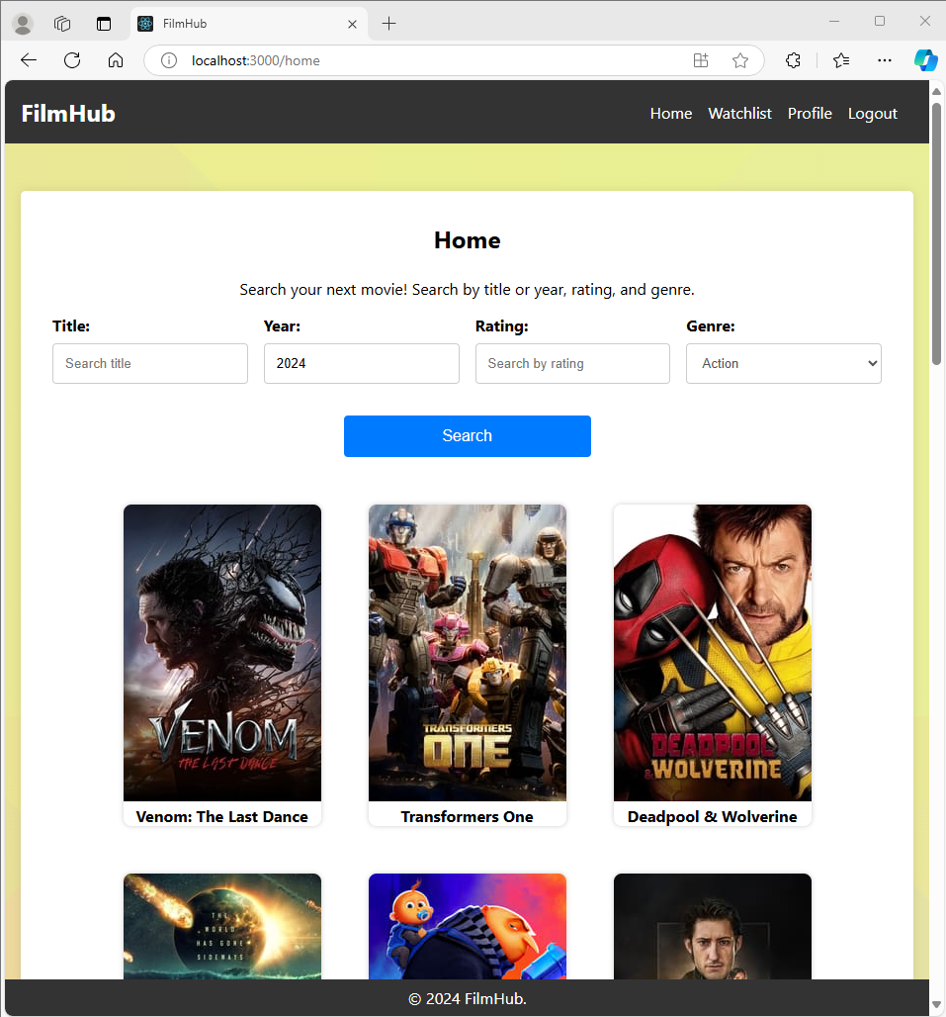

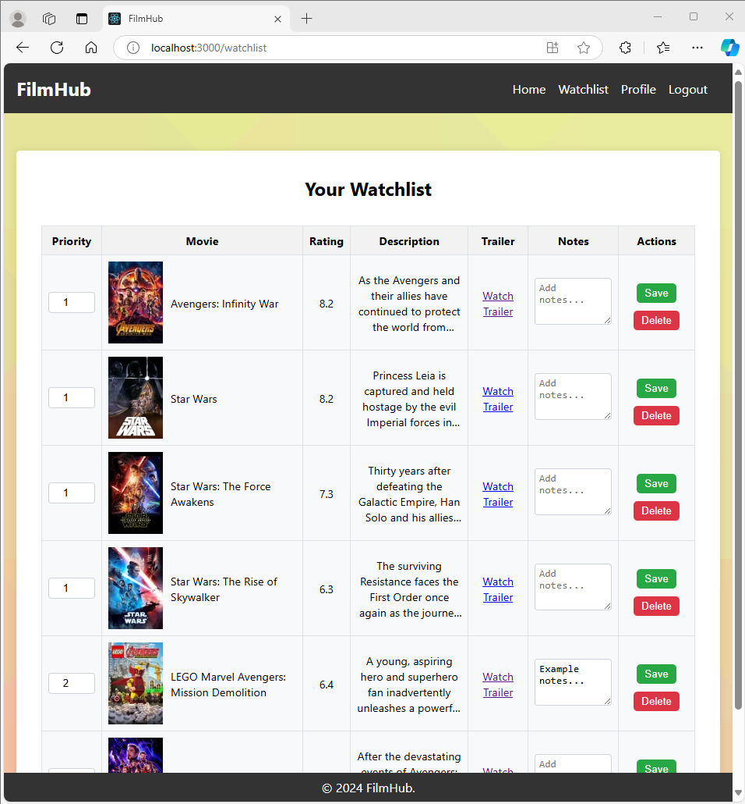

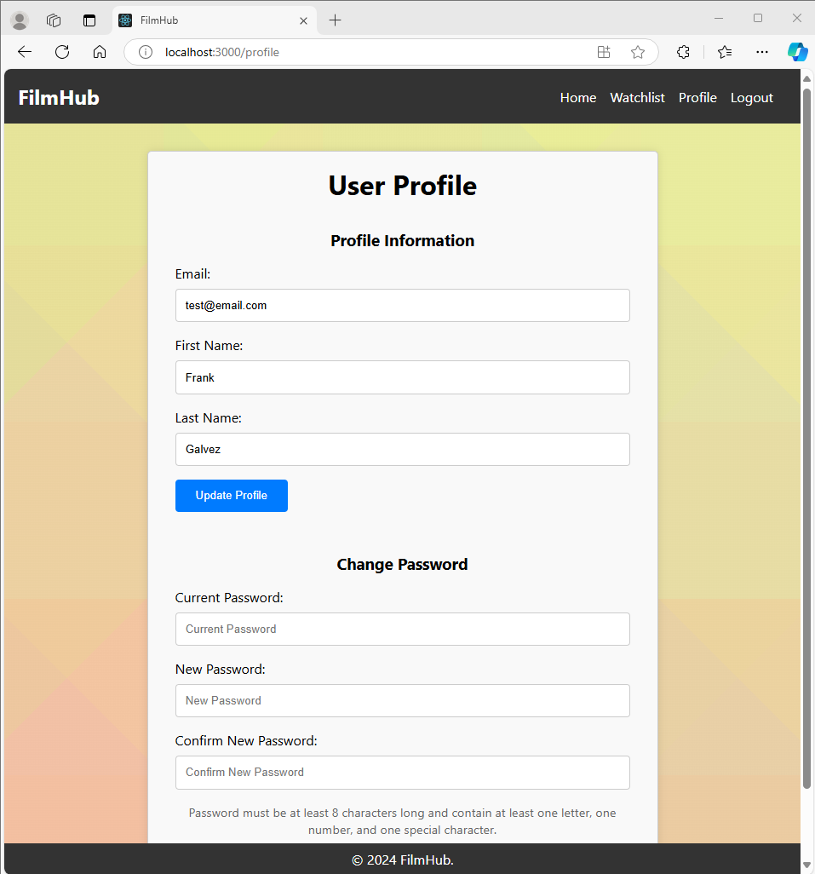

Database showing 12 objects/users and 12 objects/movies for my watchlist:
